Product name: | Euphoria SoStoned Energy Drink
Company: | EUPHORIA TRADE s.r.o.  Klimentská 46, 110 02 Prague 1, Czech Republic
Country of origin | Czech Republic
Type | 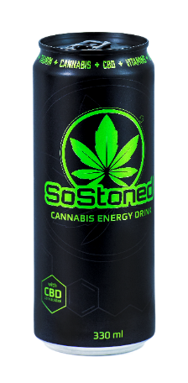  A carbonated energy drink containing caffeine, taurine, hemp aroma,  sweeteners and vitamins.
Group | Carbonated drinks
Product Ingredients | Drinking water, sugar, hemp aroma, caramel dye,  acids: citric acid, lemon trisodium, taurine (4 mg / ml), caffeine (0.32 mg / ml), vitamins:  pantothenic acid, CBD (50 mg), vitamin B6, vitamin B2, vitamin B12, preservatives: potassium sorbate, sodium benzoate, sweeteners: aspartame, acesulfame.
Product durability | 24 months from date of production
Storage conditions | Dry, 5 ° to 30 ° C, without direct sunlight
PHYSICAL AND CHEMICAL PROPERTIES
Tag |  |  | Permitted range | Frequency of tracking |  | Method of determination
Impurities, admixtures | Metal |  | 0% | Each product |  | metaldetector
 | Pests |  | 0% | Each batch |  | sensory
 | Mineral impurities |  | 0% | Each batch |  | sensory
 | Other impurities |  | Max. 0,1% | Each batch |  | sensory
NUTRITION VALUES (per 100 ML of product)
An energy value | 136 kJ
Fats | 0 g
Of this, saturated fatty acids | 0 g
Carbohydrates | 8 g
Of which sugars | 8 g
Protein | 0 g
Salt | 0 g
Fiber | 0 g
DECLARATION
ONIZING RADIATION |  | The product is treated with ionizing radiation |  |  |  |  | NO
GMO |  | The product contains GMO |  |  |  |  | NO
ALERGENS |  | Allergen in product (from recipe) |  |  | Allergen presence in the production hall
Cereals containing gluten |  | - |  |  | -
Crustaceans and products thereof |  | - |  |  | -
Eggs with products from them |  | - |  |  | -
Fish and related products |  | - |  |  | -
Peanuts |  | - |  |  | -
Dry nuts and products thereof |  | - |  |  | -
If so, which |  | - |  |  | -
Milk and products thereof |  | - |  |  | -
Soya beans and products thereof |  | - |  |  | -
Celery and products from it |  | - |  |  | -
Mustard and products thereof |  | - |  |  | -
Sesame seeds and products thereof |  | - |  |  | -
Sulfur dioxide and sulphites |  | - |  |  | -
Molluscs and products thereof |  | - |  |  | -
Lupine and products thereof |  | - |  |  | -

